(Approx. 832 words)

Word 2010 Screen Shots and Screen Clipping
By Lynn Page, Newsletter Editor/Webmaster, Crystal River Users Group, FL
December 2011 issue, CRUG newsletter
www.crug.com
editor@crug.com

Windows 7 has the Snipping Tool which is handy to capture all or part of the visible screen. Use it to capture a screen shot of any object on your screen, and then annotate, save, or share the image. These snips are great for illustrating what you’re talking about. I use them all of the time in writing articles or class documents.

Office 2010 brings the ability to make screenshots or snips directly into Excel, Outlook, PowerPoint, and Word. Take a picture of all or part of the open windows. Clicking the Screenshot button lets you select and insert an entire program window or use the Screen Clipping tool to select part of the window. The windows must be open and not minimized to the taskbar to be captured.

Both of Windows Snipping Tool and Office 2010’s Screen Shots and Screen Clipping are valuable when trying to explain something seen on the computer screen.

Capture a Screenshot within Word
The Screenshot tool is located in the Illustrations group on the Insert tab. Clicking the Screenshot icon opens a drop down preview with thumbnails of open windows that are ‘behind’ the Word document. Unfortunately you cannot capture from the current Word document and it is not among the thumbnails. Mousing over a thumbnail, opens a tooltip with the program name and document title. Select from the available screenshots to add a shot of the entire window to the document. The screenshot of the selected window will be automatically sized to the width of the document and pasted at the location of the insertion point.

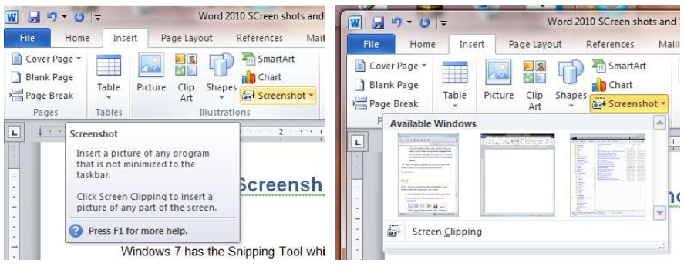

Screen Clipping in Word
To insert a clip of a part of an open window, choose Screen Clipping. If you have multiple windows open, the window to make the click from needs to be in front of other windows with the exception of the working Word document. So click on that window before clicking Screen Clipping in the working document.

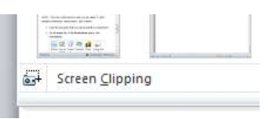
After clicking Screen Clipping, the working Word document is minimized and only the windows behind it are available for clipping. The entire screen is opaque and greyed out. The pointer becomes a cross. With it press and hold the left mouse button while dragging to select the area of the screen to capture. The selection then shows through the opaqueness. When the mouse button is released the snip is pasted into the document.

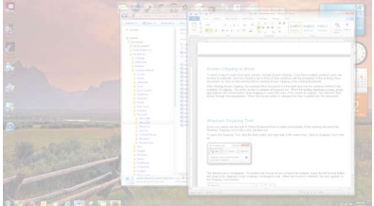

Windows Snipping Tool
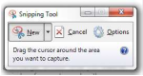
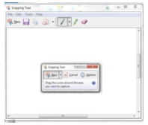
Since you cannot use the built in Office Screenshot tool to make screenshots of the working document the Windows Snipping tool is still a very valuable tool. To open the Snipping Tool, click the Start button and type snip in the search box. Click on Snipping Tool in the list. The default snip is rectangular. So position the mouse at one corner to be snipped, press the left mouse button and drag to the diagonal corner creating a rectangle to snip. When the mouse is released, the snip appears in the Snipping Tool window. To discard the current snip and create a new one click the New ‘Scissors’ button.

Annotating a Snip
It may be useful to highlight certain elements in the screen shot. With the Snipping tool you can draw a freehand circle, arrow or even write with the pen tool. Just click and drag on the screenshot. The standard pen is blue but I selected red and drew out a circle around the pen, highlighter and eraser tools. The Snipping Tool highlighter is yellow and can be used like a regular highlighter to bring attention to certain areas. The Eraser erases pen and highlighter markings but does not modify the original snip.
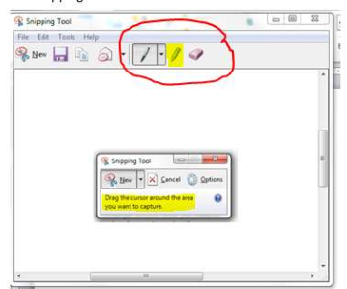

Types of Snips
The default snip is Rectangular but Free-form, Window and Full-screen snips are available. To choose which snip to use, click the down arrow by the New button. To use the Free-form Snip draw a shape around an object on the screen with the scissors icon. When using the Window Snip to select a whole window, like an application window or dialog box, click in it with the hand icon. The Full-screen Snip automatically captures the
entire screen.
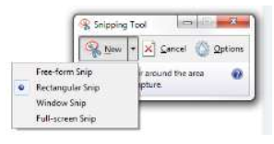
Once a screen shot has been taken using the Snipping Tool, it’s on the clipboard. So you can paste it straight into a Microsoft Word document or your Outlook email. The annotations added to the screen shot are included on the clipboard.

Saving the Snip
To save a screen shot as an image, select Save As in the File drop down menu. Then in the Save As dialog box type in a name for the image and specify a location for it to be saved. If you do not save the clip and close Snipping tool you will be prompted to save it. The File drop down menu also contains Send To. Click it to open your default email application and send the snip.

